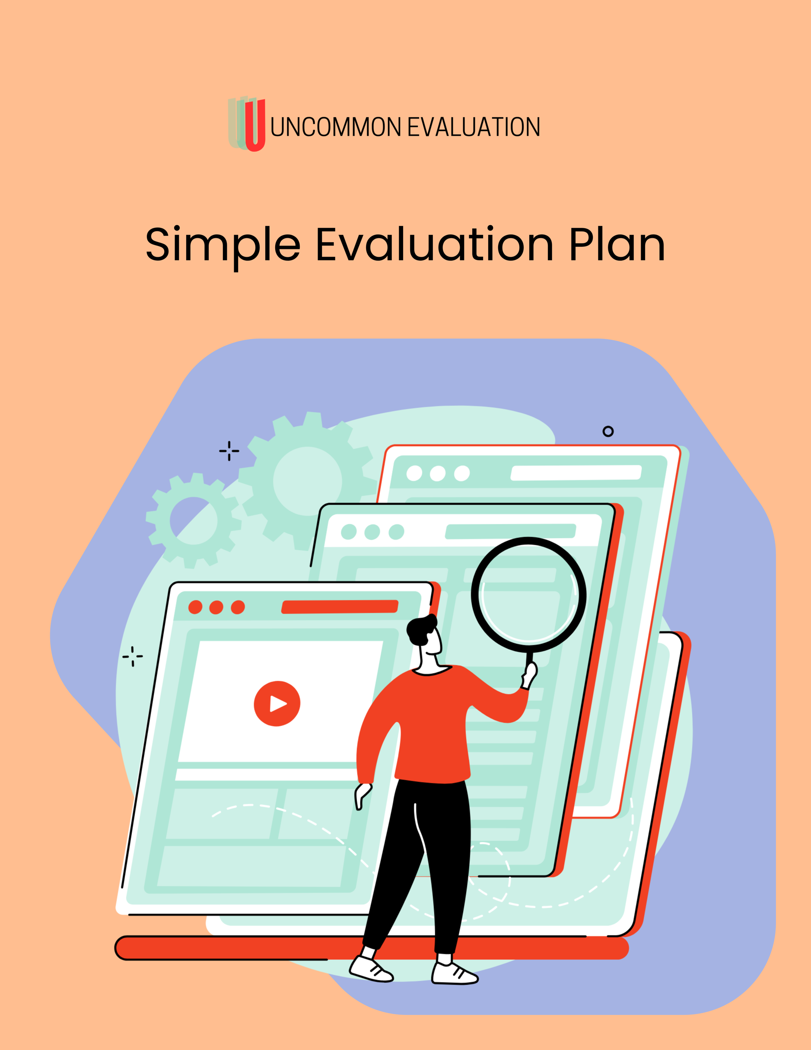

Let’s Make a Plan (Yes, an Evaluation Plan)

Welcome to the Uncommon Evaluation Simple Evaluation Plan—the no-fuss, no-fluff template designed for people who didn’t mean to become “the evaluation person” but somehow are. Whether you’re building a new program, trying to impress a funder, or just want to make sure you’re doing what you said you’d do (more or less), this plan will help you lay out your outcomes, how you’ll measure them, and what data you’ll collect along the way.

This isn’t meant to be a thesis. There are no grades, no academic citations, and no one will ask you to define epistemology. You’ll just walk through a few key questions, fill in what you know, and maybe even feel a little more organized and confident by the end. It’s okay if your answers aren’t perfect or final—evaluation is an evolving process, and your plan can grow with your program.

Use this document to clarify your goals, communicate with funders or stakeholders, and make better decisions with the data you already have (or could realistically collect without weeping). Print it, share it, or stick it in a drawer for three months—just know that when you're ready to show your work, this plan has your back.

Pro tip: Your evaluation plan won’t win a Nobel Prize. Good thing that’s not the goal.
The goal is to trust yourself because you know more than you think.

Part I – The Easy Stuff

Program Name
Insert the name of your program, project, or initiative.

Timeframe
What timeframe for the project are you evaluating? Is it a mid-year or mid-project evaluation, or an annual or project-end evaluation?

Evaluation Contact

Name and role of the person leading the evaluation (even if it’s unofficial).

Purpose of the Evaluation
What do you want to learn or understand from this evaluation? Are you trying to improve the program? Meet a funder requirement? Understand your outcomes? Example: We want to understand whether our youth mentorship program is improving participants’ sense of belonging and confidence over the course of 6 months.

Part II - Key Evaluation Questions

What are the 2–3 core questions you want to answer?
What changed for participants? Did the program reach the people it intended to? How was the program implemented?
Example:
- Did participants report increased confidence after completing the program?
- What aspects of the program did participants find most helpful?
- Were there any barriers to regular attendance?

1.

2.

3.

Activities & Outputs
What are you doing? List the core activities you deliver. And then add the associated outputs, which are the countable things (e.g., number of workshops, number of participants served, number of client contacts, etc). Example:
Activities | Outputs (What You Can Count)
Weekly youth circles | 12 sessions delivered over 3 months
Mentorship pairings | 15 youth matched with adult mentors
Resource kits distributed | 50 kits shared with families
The table for you to complete is below. Add as many rows as you need to enter all of your program or agency’s activities. Once you’ve completed it, you can delete the example table above so that it’s not cluttering up your amazing evaluation plan. And on that note, delete all of this text too.

Activities | Outputs

Outcomes
What changes do you hope to see as a result of the program? Focus on short- to medium-term outcomes (the things that are realistic to measure now). Example:
Outcome Statement | How You’ll Know (Indicators)
Youth feel more confident interacting with peers | Survey question: “I feel confident speaking in groups”
Families feel more supported by the program | End-of-program interviews or feedback forms
Participants build positive relationships with mentors | Attendance + satisfaction feedback from both parties

Remember: complete the table below for your agency or program, and then delete the example one above to keep this plan neat and tidy.

Outcome Statement | How You’ll Know (Indicators)

Part III - Data Collection Methods
How will you gather information to answer your evaluation questions? Example:
Method | Who’s Involved | When
Pre/post surveys | Youth participants | Start and end of program
End-of-program survey | Parents/caregivers | Final week of programming
Attendance tracking | Staff | Ongoing
Interviews | 3–5 youth, 3 mentors | After program wraps

Use the examples above to complete the data collection table for your program or agency. Don’t forget to delete the table above when you’re done!

Method | Who’s Involved | When

Part IV - How You’ll Use the Results
What will you do with what you learn? Share with funders? Improve future programming? Create a report?
Example:
We’ll use the results to improve mentor training, support a new funding application, and share success stories in our annual report.

Part V – Next Steps

Congrats! You now have a simple, clear evaluation plan. So what now?

First, take a moment to feel smug. You’ve created something that gives structure to your program’s story—and you hopefully didn’t even feel the need to cry in the process. That alone is worth a high five.
Now, depending on where you are in your evaluation journey, here are a few smart next steps:
- Share the plan with your team. Use it to spark conversations about outcomes, roles, and what data you’re already collecting without even realizing it.
- Build out your tools. Create a simple survey, tracking sheet, or interview guide based on your indicators.
- Start collecting and organizing your data. Don’t worry if it’s messy. It always is at first.
- Turn your plan into a logic model. If you're feeling bold—or bored—we’ve got a template for that too.
- Not sure what to do with the data once you collect it? That’s where our Reporting Toolkit or Evaluation Sprint might come in handy.
And remember: you don’t have to do all the things all at once. Evaluation is a process, not a performance. Come back to this plan, update it as you learn, and use it as a map—not a monument.

Need a bit more support with your next steps? We’ve got toolkits, courses, and real humans to help. Visit uncommonevaluation.com for more ways to keep this momentum going.

